The Breakfast Club
Presents

The First

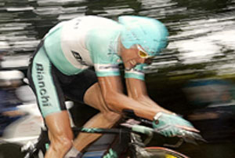

The Alabang ITT Cup is a yearlong event which consists of 9 Individual Time Trials. Our unique format gives everyone a chance to win. We have five amateur and one elite category. The Philippine team rider and the club rider both compete on the same stage.

Featuring the best prize ever offered in Philippine amateur cycling:

1st place

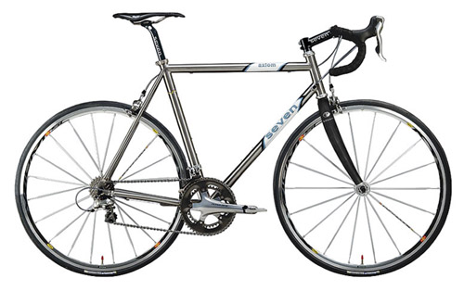
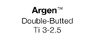

A custom seven cycles axiom Titanium frame with an Easton Ultra light fork


Made to measure and built for the winner of the Alabang ITT CUP
Specifications:
Designed just for the winner, completely custom
One bike, your bike.

The Breakfast Club is a non-stock, non-profit organization. Our organization has two aims. The first is to encourage people to enjoy the sport of cycling through fun and safe events. Our second goal is to give back to the community a little bit of the joy we get from our sport.

A portion of the proceeds of this event will go to our charity project: Bikes for Orphans. Our project will collect used, unwanted and damaged bicycles. We will buy new parts, paint and refurbish the bikes for distribution to orphanages around the Metro Manila area.

Our first beneficiary will be the SOS Children’s Village in Alabang. They have 110 kids. The kids in SOS are both boys and girls. Their ages range from 6 to 21.

Riding our bikes is our idea of nirvana. It is one of our most enjoyable activities. We are inviting you to share your love of bicycling with kids who may never have the opportunity to feel the joy you feel when you pedal your bike.

Your participation in our time trial series will go a long way towards helping a lot of deserving kids.

Please contact us if you have any used or damaged bicycles you wish to donate. We can pick them up from your house. Or you can drop them in Tonji Ramos house located at 309 Sampaguita Street, Ayala Alabang Village. His contact number is 9189173920. Email is tonji@mydestiny.net.

Race details:

The racecourse is 15 kilometers. It is a rolling course with no long climbs. It has a total elevation gain of around 200ft. It is a fast track and is an excellent test against the clock. We have a very light and fun atmosphere in the race. With six categories all skill levels are welcome.

We will issue a time schedule 4 days before each race. Early slots can be reserved until one week before the race. Early payment of fees will be entitle the participant to register in advance. The participant can register early for all 9 races. Participants who register late will be given the time slots after the early registrants. We encourage everyone to register early because the wind kicks up as the day goes on making it just that much harder. Registration will initially be at Velocity Bike shop in Cartimar. We will expand and update the list of registration outlets this week.

Fee: the cost is only P200 per race

Prizes: 1st Place One custom ordered SEVEN AXIOM frame. With an EASTON fork and EASTON stem. The total retail price in the US is over $3150.00. It is P177, 000.00 worth of first class, top of the line bike.
One bike, your bike.

(The prize does not include the Dura Ace 10 speed stuff or the hot Mavic wheelset seen in the picture.)

The prize for the elite division will be announced next month.

Details of the points system and seeding will be given during the race.

All participants must be tested and seeded to get points. Our next seeding race will be March 21, 2004. Please join this seeding race so you can get seeded and get maximum points towards winning the SEVEN AXIOM on our official start on April 25, 2004. Late registration is at 6:00 a.m. on March 21, 2004.

How to get there:
From Alabang Town Center, take Commerce Avenue and turn left at the end towards Southvale Village. The ITT start/finish line is at the entrance Southvale Village. If there is a start/finish line change, organizers will announce changes in due time.

